**List, Tuples, Strings, Classes, and Inheritance**

**ITM205: Object Oriented Programming**

**Professor: Dr. Santos Galvez**

**By Odiscious Dozier**

**Trident University**

**Case 04 – Exercises**

**1 - String Examples.py File**

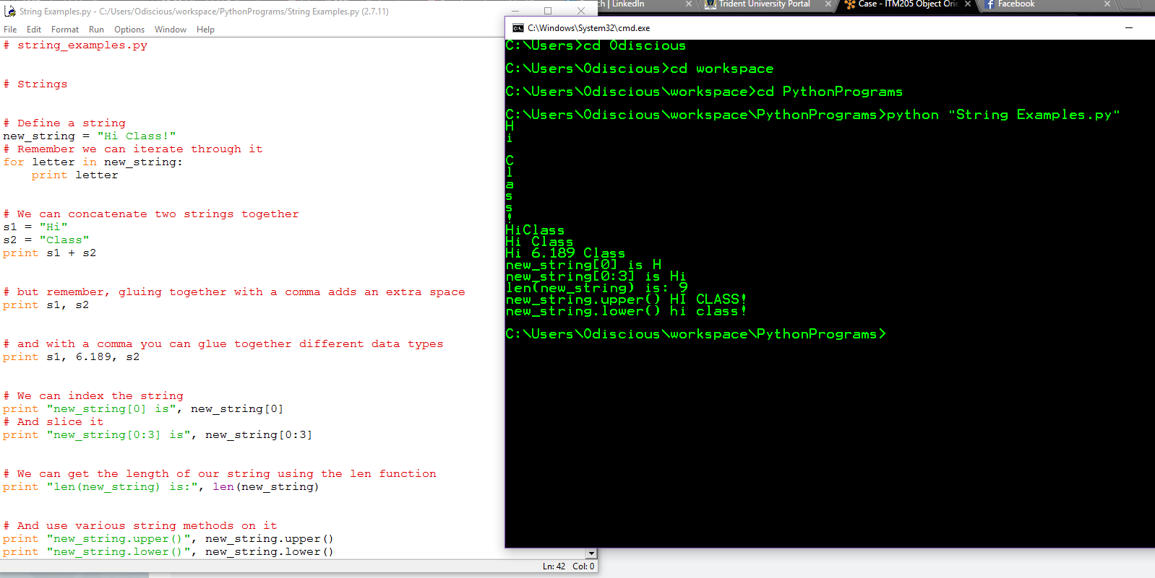

Modified

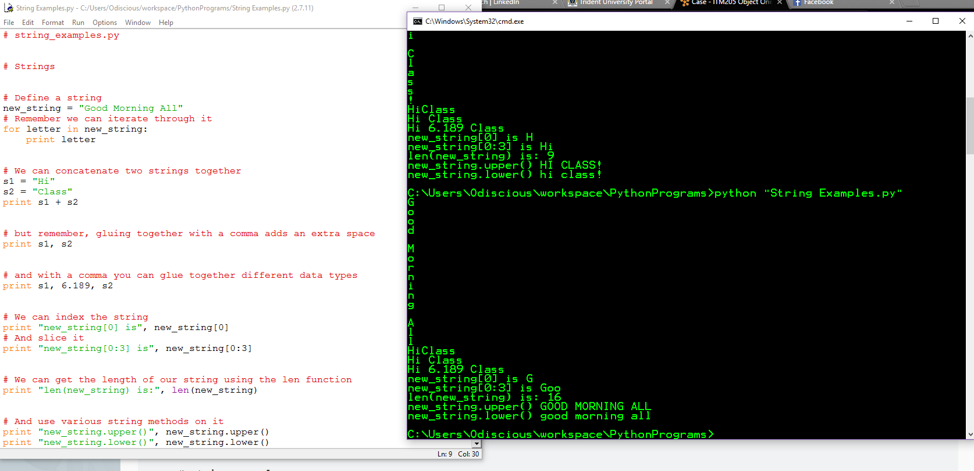

**2 - List Examples.py File**

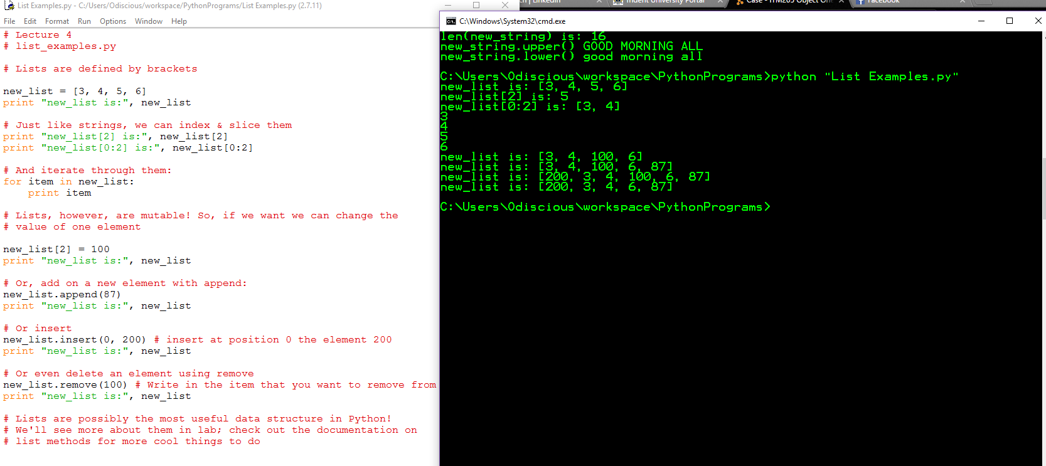

Modified

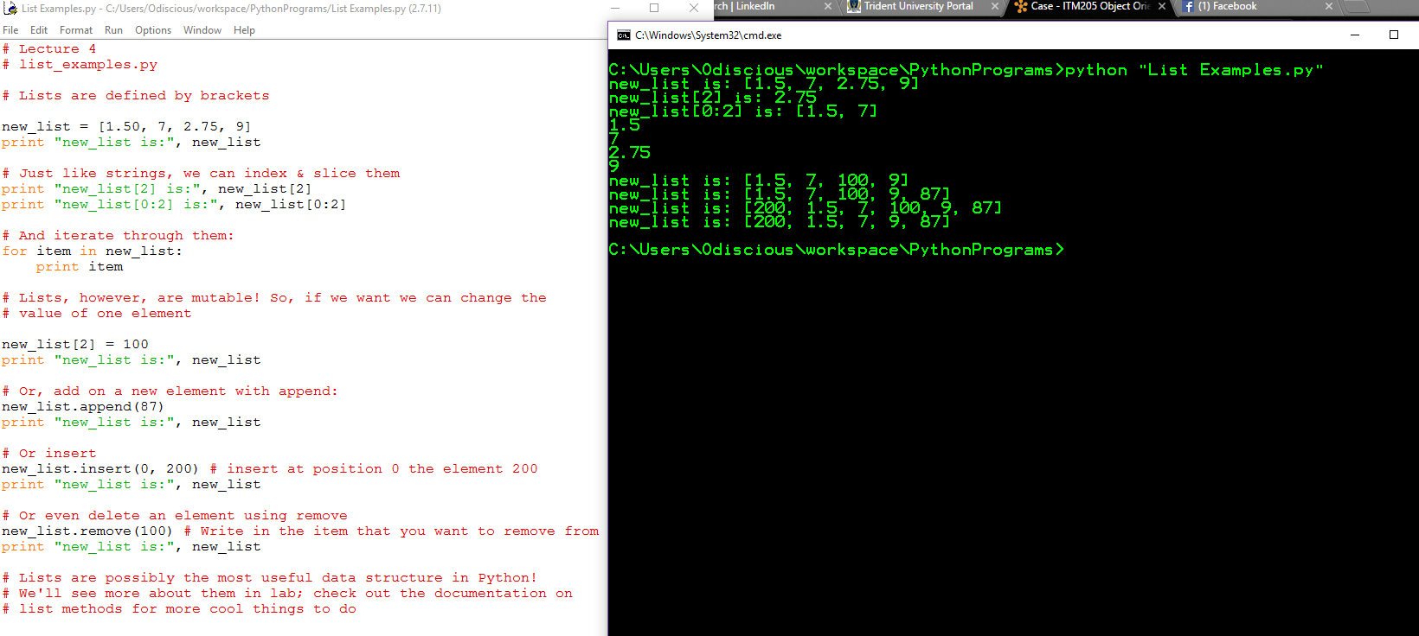

**3 –** **Tuple Examples.py File**

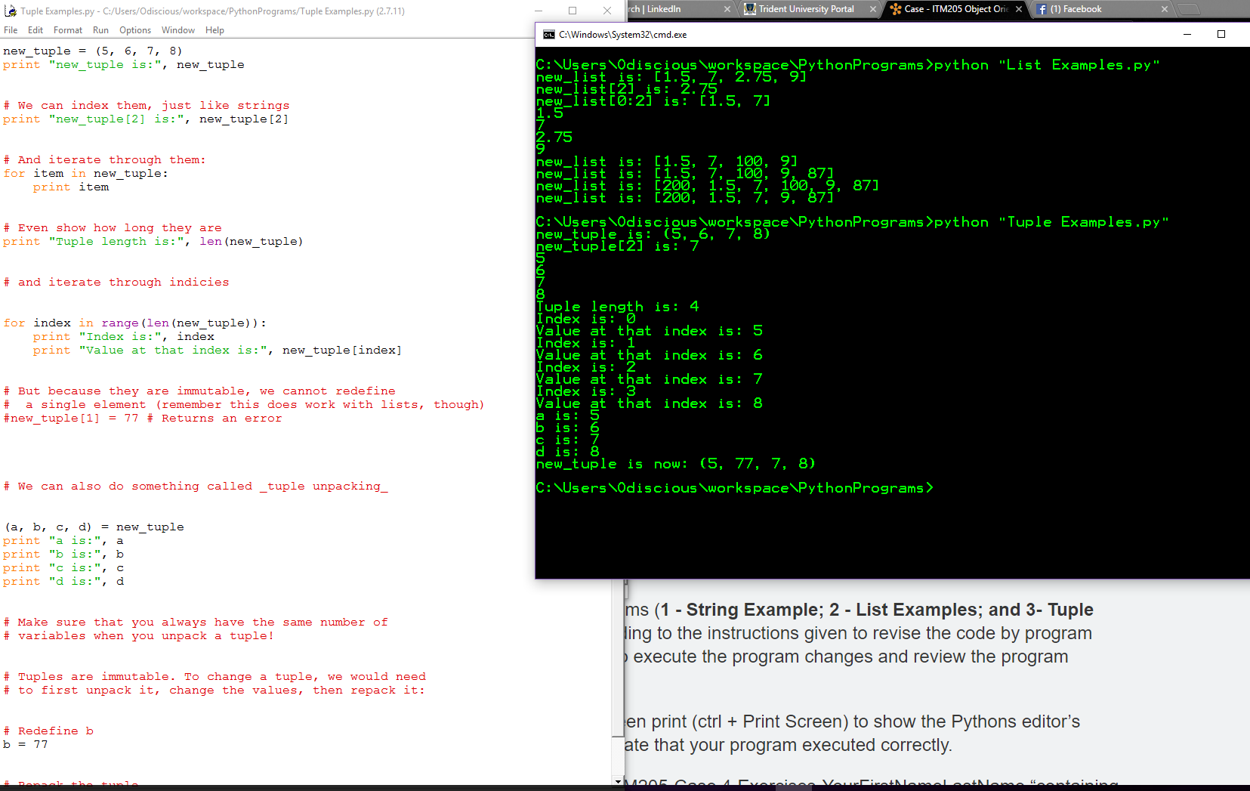

Modified

